Homework 1

Yue Peng

a.

| Day | Pain Score |
| --- | --- |
| 1 | 8.94 |
| 2 | 7.99 |
| 3 | 7.49 |
| 4 | 7.32 |
| 5 | 6.79 |
| 6 | 7.02 |
| 7 | 6.50 |

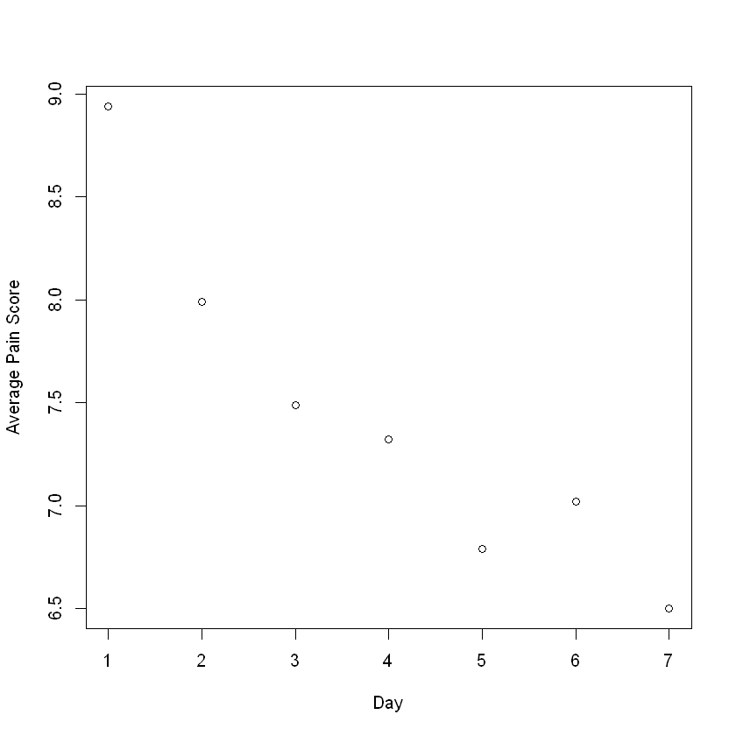

According to the graph above, the average pain score decreases over time.

b.

Call:

lm(formula = Big$pain.1 ~ Big$age)

Residuals:

Min 1Q Median 3Q Max

-8.1071 -2.1278 0.1408 2.0168 11.3887

Coefficients:

Estimate Std. Error t value Pr(>|t|)

(Intercept) 10.18148 1.54445 6.592 3.66e-10 ***

Big$age -0.02066 0.02535 -0.815 0.416

---

Signif. codes: 0 '***' 0.001 '**' 0.01 '*' 0.05 '.' 0.1 ' ' 1

Residual standard error: 3.406 on 203 degrees of freedom

(1 observation deleted due to missingness)

Multiple R-squared: 0.003261, Adjusted R-squared: -0.001649

F-statistic: 0.6642 on 1 and 203 DF, p-value: 0.416

Call:

lm(formula = Big$pain.2 ~ Big$age)

Residuals:

Min 1Q Median 3Q Max

-7.9802 -2.0812 -0.2833 2.2364 12.4529

Coefficients:

Estimate Std. Error t value Pr(>|t|)

(Intercept) 9.74120 1.85034 5.265 4.59e-07 ***

Big$age -0.02887 0.03012 -0.959 0.339

---

Signif. codes: 0 '***' 0.001 '**' 0.01 '*' 0.05 '.' 0.1 ' ' 1

Residual standard error: 3.603 on 156 degrees of freedom

(48 observations deleted due to missingness)

Multiple R-squared: 0.005856, Adjusted R-squared: -0.000517

F-statistic: 0.9189 on 1 and 156 DF, p-value: 0.3393

Call:

lm(formula = Big$pain.3 ~ Big$age)

Residuals:

Min 1Q Median 3Q Max

-7.6946 -2.4095 -0.1244 2.5646 11.2708

Coefficients:

Estimate Std. Error t value Pr(>|t|)

(Intercept) 9.56076 2.04640 4.672 6.46e-06 ***

Big$age -0.03456 0.03378 -1.023 0.308

---

Signif. codes: 0 '***' 0.001 '**' 0.01 '*' 0.05 '.' 0.1 ' ' 1

Residual standard error: 3.805 on 154 degrees of freedom

(50 observations deleted due to missingness)

Multiple R-squared: 0.006751, Adjusted R-squared: 0.0003016

F-statistic: 1.047 on 1 and 154 DF, p-value: 0.3079

Call:

lm(formula = Big$pain.4 ~ Big$age)

Residuals:

Min 1Q Median 3Q Max

-7.7484 -2.4767 -0.0517 2.7741 11.4746

Coefficients:

Estimate Std. Error t value Pr(>|t|)

(Intercept) 9.00243 1.93074 4.663 6.44e-06 ***

Big$age -0.02787 0.03156 -0.883 0.379

---

Signif. codes: 0 '***' 0.001 '**' 0.01 '*' 0.05 '.' 0.1 ' ' 1

Residual standard error: 3.797 on 164 degrees of freedom

(40 observations deleted due to missingness)

Multiple R-squared: 0.004731, Adjusted R-squared: -0.001338

F-statistic: 0.7795 on 1 and 164 DF, p-value: 0.3786

Call:

lm(formula = Big$pain.5 ~ Big$age)

Residuals:

Min 1Q Median 3Q Max

-7.109 -2.850 -0.321 2.727 10.948

Coefficients:

Estimate Std. Error t value Pr(>|t|)

(Intercept) 10.22071 1.94014 5.268 4.58e-07 ***

Big$age -0.05762 0.03220 -1.790 0.0755 .

---

Signif. codes: 0 '***' 0.001 '**' 0.01 '*' 0.05 '.' 0.1 ' ' 1

Residual standard error: 3.674 on 154 degrees of freedom

(50 observations deleted due to missingness)

Multiple R-squared: 0.02038, Adjusted R-squared: 0.01402

F-statistic: 3.203 on 1 and 154 DF, p-value: 0.07546

Call:

lm(formula = Big$pain.6 ~ Big$age)

Residuals:

Min 1Q Median 3Q Max

-6.3490 -3.1335 -0.2341 2.6366 10.7659

Coefficients:

Estimate Std. Error t value Pr(>|t|)

(Intercept) 8.75729 1.96991 4.446 1.68e-05 ***

Big$age -0.02874 0.03226 -0.891 0.374

---

Signif. codes: 0 '***' 0.001 '**' 0.01 '*' 0.05 '.' 0.1 ' ' 1

Residual standard error: 3.854 on 153 degrees of freedom

(51 observations deleted due to missingness)

Multiple R-squared: 0.00516, Adjusted R-squared: -0.001342

F-statistic: 0.7936 on 1 and 153 DF, p-value: 0.3744

Call:

lm(formula = Big$pain.7 ~ Big$age)

Residuals:

Min 1Q Median 3Q Max

-6.8762 -3.2389 -0.4889 2.9153 11.1791

Coefficients:

Estimate Std. Error t value Pr(>|t|)

(Intercept) 9.86413 2.23231 4.419 1.96e-05 ***

Big$age -0.05533 0.03630 -1.524 0.13

---

Signif. codes: 0 '***' 0.001 '**' 0.01 '*' 0.05 '.' 0.1 ' ' 1

Residual standard error: 4.015 on 142 degrees of freedom

(62 observations deleted due to missingness)

Multiple R-squared: 0.0161, Adjusted R-squared: 0.009169

F-statistic: 2.323 on 1 and 142 DF, p-value: 0.1297

|  | estimate | standard errors | p-values | 95% confidence intervals |
| --- | --- | --- | --- | --- |
| pain.1 | -0.021 | 0.025 | 0.416 | (-0.071, 0.029) |
| pain.2 | -0.029 | 0.030 | 0.339 | (-0.088, 0.031) |
| pain.3 | -0.035 | 0.034 | 0.308 | (-0.101, 0.032) |
| pain.4 | -0.028 | 0.032 | 0.379 | (-0.09, 0.034) |
| pain.5 | -0.058 | 0.032 | 0.075 | (-0.121, 0.006) |
| pain.6 | -0.029 | 0.032 | 0.374 | (-0.092, 0.035) |
| pain.7 | -0.055 | 0.036 | 0.130 | (-0.127, 0.016) |

From the table above, it tells us that the pain is negatively correlated with age on each day, but they are not statistically significant because the p-values are all greater than 0.05.

c.

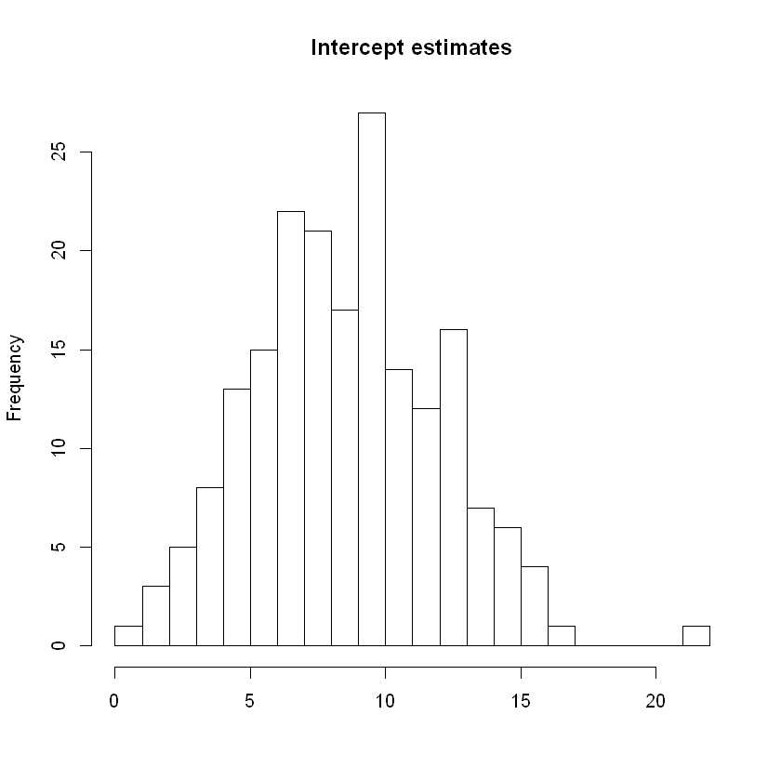

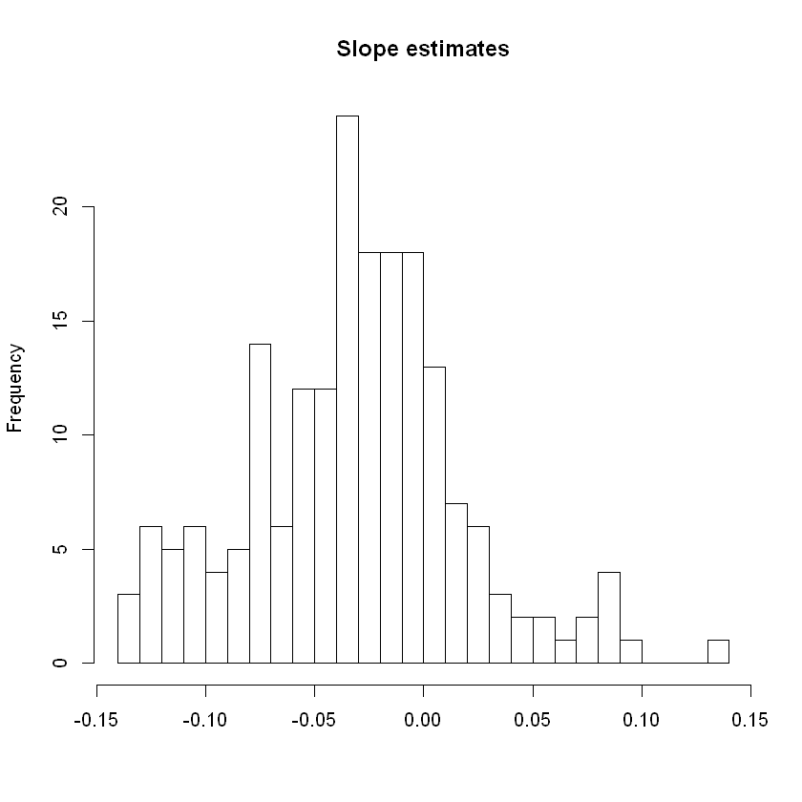

The slopes range mainly from (-0.05, 0.01) which are quite small, indicating that pain scores change very little by day. More people have less pain by time than people have more pain by time, which also support the situation that trend is decreasing.

d.

Occupation has too many categories, which is not suitable to fit in a regression model. Thus, I decided not to use this variable in analysis progress.

|  | P-values of intercepts | P-values of slopes | Related to intercept | Related to slope |
| --- | --- | --- | --- | --- |
| Age | 0.805 | 0.772 | Not related | Not related |
| Race | 0.762 | 0.523 | Not related | Not related |
| Income | 0.290 | 0.925 | Not related | Not related |
| Treatment | 0.484 | 0.383 | Not related | Not related |
| Sex | 0.210 | 0.824 | Not related | Not related |
| Working Status | 0.232 | 0.472 | Not related | Not related |
| Use of NSAIDs | 0.373 | 0.029 | Not related | Related |

Conclusion: use of NSAIDs is correlated with the slope.

e.

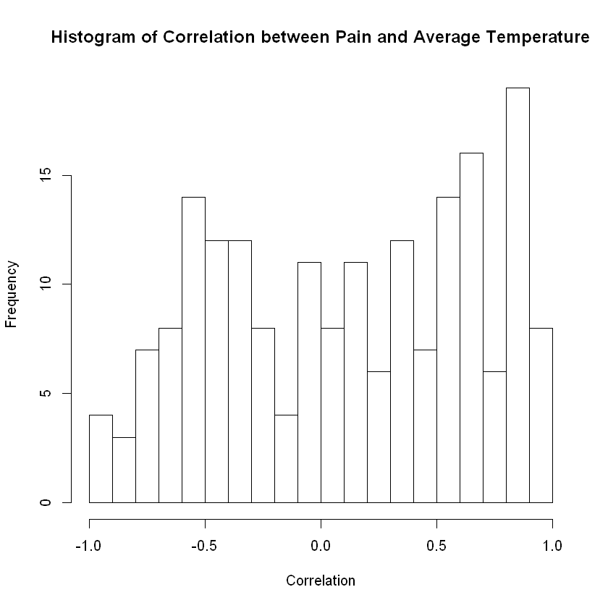

The frequency of positive correlations is higher than negative correlations. And the frequency from -0.5 to 0.5 is quite symmetric. It is not clear here but I think there may be correlations between them because a large amount of individuals showed that there are correlations.

2.

Table 2

| Varibale | Tai chi | Control | Tai chi vs Control | P-value |
| --- | --- | --- | --- | --- |
| WOMAC-Pain, 0-500 mm Week 12 | -157.25 (-198.51 to -115.99) | -38.45 (-87.18 to 10.28) | -118.8 (-180.77 to -56.83) | 0.00074 |
| Week 24 | -131.55 (-179.63 to -83.47) | -64.6 (-116.08 to -13.12) | -66.95 (-129.89 to -4.01) | 0.038 |
| Week 48 | -115.35 (-172.19 to -58.51) | -69.2 (-126.53 to -11.87) | -46.15 (-126.44 to 34.14) | 0.24 |
| WOMAC-Physical Function, 0-1700 mm, Week 12 | -506.75 (-635.52 to -377.98) | -182.15 (-321.8 to -42.5) | -324.6 (-490.76 to -158.44) | 0.00063 |
| Week 24 | -440.5 (-582.58 to -298.42) | -257.3 (-408.63 to -105.97) | -183.2 (-363.18 to -3.22) | 0.046 |
| Week 48 | -405.85 (-577.68 to -234.02) | -300.55 (-452.98 to -148.12) | -105.3 (-296.03 to 85.43) | 0.26 |
| WOMAC-Stiffness, 0-200 mm Week 12 | -73.05 (-90.49 to -55.61) | -50.15 (-75.84 to -24.46) | -22.9 (-48.18 to 2.38) | 0.073 |
| Week 24 | -65 (-87.16 to -42.84) | -50.2 (-72.99 to -27.41) | -14.8 (-43.12 to 13.52) | 0.29 |
| Week 48 | -64.15 (-86.18 to -42.12) | -60.5 (-88.89 to -32.11) | -3.65 (-40.03 to 32.73) | 0.84 |
| Physician, 0-10 cm VAS Week 12 | -3.15 (-3.88 to -2.41) | -1.44 (-2.1 to -0.78) | -1.71 (-2.73 to -0.68) | 0.0025 |
| Week 24 | -2.6 (-3.37 to -1.82) | -2.06 (-2.95 to -1.17) | -0.53 (-1.65 to 0.58) | 0.33 |
| Week 48 | -2.54 (-3.62 to -1.45) | -1.54 (-2.25 to -0.83) | -0.98 (-2.19 to 0.22) | 0.1 |
| Patient Global, 0-10 cm VAS Week 12 | -2.98 (-3.94 to -2.02) | -0.83 (-1.86 to 0.21) | -2.15 (-3.47 to -0.83) | 0.0029 |
| Week 24 | -2.36 (-3.63 to -1.09) | -1.71 (-2.98 to -0.44) | -0.65 (-2.23 to 0.93) | 0.4 |
| Week 48 | -1.65 (-3.4 to 0.09) | -1.7 (-3.15 to -0.24) | 0.04 (-2.17 to 2.25) | 0.97 |
| 6 Minute Walk Test(yards) Week 12 | 40.28 (9.3 to 71.27) | -1.42 (-42.17 to 39.33) | 41.12 (-18.33 to 100.57) | 0.16 |
| Week 24 | 44.28 (8.36 to 80.19) | 7.84 (-27.9 to 43.58) | 36 (-22.87 to 94.87) | 0.22 |
| Week 48 | 28.75 (-12.45 to 69.94) | 17.14 (-17.27 to 51.55) | 4.73 (-56.23 to 65.68) | 0.87 |
| Balance Score, 0-5 Week 12 | 0.15 (-0.08 to 0.38) | 0.25 (-0.05 to 0.55) | -0.1 (-0.53 to 0.33) | 0.63 |
| Week 24 | 0.15 (-0.16 to 0.46) | 0.07 (-0.37 to 0.52) | 0.07 (-0.52 to 0.67) | 0.8 |
| Week 48 | 0.35 (0.04 to 0.66) | 0.47 (0.07 to 0.88) | -0.16 (-0.72 to 0.4) | 0.56 |
| Chair Stand Time(seconds) Week 12 | -12.03 (-16.68 to -7.39) | -0.94 (-4.84 to 2.97) | -11.1 (-16.64 to -5.56) | 0.00053 |
| Week 24 | -9.88 (-14.08 to -5.67) | -4.81 (-9.28 to -0.33) | -5.07 (-10.9 to 0.77) | 0.085 |
| Week 48 | -9.23 (-14.62 to -3.83) | -3.8 (-8.01 to 0.41) | -4 (-9.49 to 1.48) | 0.14 |
| SF-36 Mental Component Summary, 0-100 Week 12 | 2.14 (-4.02 to 8.31) | 1.93 (-2.62 to 6.49) | 0.21 (-7.12 to 7.54) | 0.95 |
| Week 24 | 4.39 (-2.06 to 10.84) | 4.5 (0.87 to 8.13) | -0.11 (-7.57 to 7.35) | 0.98 |
| Week 48 | 5.8 (-0.46 to 12.07) | 1.04 (-5.07 to 7.14) | 4.77 (-5.03 to 14.57) | 0.32 |
| SF-36 Physical Component Summary, 0-100 Week 12 | 11.57 (7.61 to 15.53) | 4.14 (0.68 to 7.6) | 7.43 (1.75 to 13.11) | 0.013 |
| Week 24 | 10.8 (6.69 to 14.91) | 6.29 (1.98 to 10.59) | 4.51 (-2.35 to 11.37) | 0.18 |
| Week 48 | 10.41 (5.64 to 15.18) | 4.1 (0 to 8.2) | 6.32 (-0.45 to 13.08) | 0.065 |
| CES-D, 0-60 Week 12 | -7.4 (-11.38 to -3.42) | -0.7 (-3.88 to 2.48) | -6.7 (-12 to -1.4) | 0.016 |
| Week 24 | -6.4 (-11.39 to -1.41) | -1.1 (-5.04 to 2.84) | -5.3 (-11.52 to 0.92) | 0.091 |
| Week 48 | -7.25 (-11.77 to -2.73) | 1.65 (-2.39 to 5.69) | -8.9 (-14.92 to -2.88) | 0.0059 |
| Self-Efficacy Score, 1-5 Week 12 | 0.6 (-0.01 to 1.21) | -0.11 (-0.53 to 0.31) | 0.71 (-0.06 to 1.48) | 0.07 |
| Week 24 | 0.68 (0.13 to 1.23) | -0.17 (-0.69 to 0.35) | 0.85 (0.08 to 1.62) | 0.032 |
| Week 48 | 0.72 (0 to 1.44) | -0.24 (-0.65 to 0.17) | 0.96 (0.18 to 1.74) | 0.018 |

Appendix (R code)

*# Homework 1 for PHP2550*

MC_Big <- read.csv("mcalindon_Big.csv")

dim(MC_Big)

*# Extract the first observation for each individual*

num <- rle(MC_Big$ID)

index <- c(cumsum(num$lengths) + 1)

index <- c(1, index)

Big <- MC_Big[index, ]

dim(Big)

*# a*

ave_pain <- round(colMeans(data.frame(Big$pain.1, Big$pain.2, Big$pain.3, Big$pain.4,

Big$pain.5, Big$pain.6, Big$pain.7), na.rm = **TRUE**),2)

df_a <- data.frame(Day=c(1:7), Pain=ave_pain)

colnames(df_a) <- c("Day", "Pain Score")

rownames(df_a) <- c(1:7)

plot(seq(7), ave_pain, xlab = "Day", ylab = "Average Pain Score")

model1 <- lm(Big$pain.1~Big$age)

print(summary(model1))

model2 <- lm(Big$pain.2~Big$age)

print(summary(model2))

model3 <- lm(Big$pain.3~Big$age)

print(summary(model3))

model4 <- lm(Big$pain.4~Big$age)

print(summary(model4))

model5 <- lm(Big$pain.5~Big$age)

print(summary(model5))

model6 <- lm(Big$pain.6~Big$age)

print(summary(model6))

model7 <- lm(Big$pain.7~Big$age)

print(summary(model7))

res_confint <- c()

get_confint <- **function**(x){

int_left <- confint(x, level=0.95)[2, 1]

int_right <- confint(x, level=0.95)[2, 2]

res_confint <- c(int_left, int_right)

**return**(res_confint)

}

model = list(model1, model2, model3, model4, model5, model6, model7)

**for** (i **in** model){

res_confint <- c(res_confint,get_confint(i))

}

res_estimate <- c()

get_estimate <- **function**(x){

res <- summary(x)[[4]][2,1]

}

**for** (i **in** model){

res_estimate <- c(res_estimate,get_estimate(i))

}

res_sd <- c()

get_sd <- **function**(x){

res <- summary(x)[[4]][2,2]

}

**for** (i **in** model){

res_sd <- c(res_sd,get_sd(i))

}

res_pvalue <- c()

get_pvalue <- **function**(x){

res <- summary(x)[[4]][2,4]

}

**for** (i **in** model){

res_pvalue <- c(res_pvalue,get_pvalue(i))

}

*# reshape and organize*

res_conf <- c()

i = 1

**while** (i <= 13){

res_conf <- c(res_conf, paste0("(",round(res_confint[i], digits = 3),", ", round(res_confint[i+1], digits = 3), ")"))

i = i + 2

}

rm(res_confint)

res_estimate <- round(res_estimate, digits = 3)

res_sd <- round(res_sd, digits = 3)

res_pvalue <- round(res_pvalue, digits = 3)

*# make it a table*

df_b <- data.frame(estimate=res_estimate, standard_errors=res_sd, p_values=res_pvalue, CI=res_conf)

rownames(df_b) <- c("pain.1","pain.2","pain.3","pain.4","pain.5","pain.6","pain.7")

colnames(df_b) <- c("estimate", "standard errors", "p-values", "95% confidence intervals")

sub_Big_time <- data.frame(Big$pain.1, Big$pain.2, Big$pain.3, Big$pain.4, Big$pain.5, Big$pain.6, Big$pain.7)

*# get rid of >= 5 NA and keep at least three point*

clean_na <- **function**(x){

**if** (sum(is.na(x)) >= 5){

**return**(1)

}else{

**return**(0)

}

}

idx1 <- c()

**for** (i **in** 1:(dim(sub_Big_time)[1])){

**if** (clean_na(sub_Big_time[i,])){

idx1 <- c(idx1, i)

}

}

*# Extract time*

time <- cbind(Big$lastdt1, Big$lastdt2, Big$lastdt3, Big$lastdt4, Big$lastdt5, Big$lastdt6, Big$lastdt7)[-idx1,]

**for** (i **in** (1:dim(time)[1])){

time[i,] <- time[i,] - rep(time[i,1],7)

}

*# make table*

df_c1 <- c()

**for** (i **in** 1:(dim(sub_Big_time[-idx1,])[1])){

df_c1<- c(df_c1, summary(lm(as.numeric(sub_Big_time[-idx1,][i,])~time[i,], na.action=na.omit))[[4]][,1])

}

tmp <- df_c1

x1 <- tmp[1]

x2 <- tmp[2]

i = 3

**while** (i <= 386){

x1 <- c(x1, tmp[i])

x2 <- c(x2, tmp[i+1])

i = i + 2

}

rm(tmp)

x1 <- round(x1, digits = 2)

x2 <- round(x2, digits = 2)

df_c <- data.frame(slopes=x2,intercepts=x1)

rownames(df_c) <- as.character(Big$ID[-idx1])

hist(df_c$intercepts, breaks = 20, xlab = "", main = "Intercept estimates")

hist(df_c$slopes, breaks = 20, xlab = "", main = "Slope estimates")

*# Race*

p_race1 <- cor.test(df_c$intercepts, Big$racecat[-idx1])[[3]]

p_race2 <- cor.test(df_c$slopes, Big$racecat[-idx1])[[3]]

*# Age*

p_age1 <- cor.test(df_c$intercepts, Big$agecat[-idx1])[[3]]

p_age2 <- cor.test(df_c$slopes, Big$agecat[-idx1])[[3]]

*# income*

p_income1 <- cor.test(df_c$intercepts, Big$inccat[-idx1])[[3]]

p_income2 <- cor.test(df_c$slopes, Big$inccat[-idx1])[[3]]

*# treatment*

p_trt1 <- cor.test(df_c$intercepts, Big$treat[-idx1])[[3]]

p_trt2 <- cor.test(df_c$slopes, Big$treat[-idx1])[[3]]

*# sex*

p_sex1 <- cor.test(df_c$intercepts, Big$sex[-idx1])[[3]]

p_sex2 <- cor.test(df_c$slopes, Big$sex[-idx1])[[3]]

*# retire*

p_retire1 <- cor.test(df_c$intercepts, Big$retire[-idx1])[[3]]

p_retire2 <- cor.test(df_c$slopes, Big$retire[-idx1])[[3]]

*# NSAIDs*

p_nsaids1 <- cor.test(df_c$intercepts, Big$nsaid[-idx1])[[3]]

p_nsaids2 <- cor.test(df_c$slopes, Big$nsaid[-idx1])[[3]]

df_d <- data.frame(intercepts=round(c(p_age1, p_race1, p_income1, p_trt1, p_sex1, p_retire1, p_nsaids1), digits = 3),

slopes=round(c(p_age2, p_race2, p_income2, p_trt2, p_sex2, p_retire2, p_nsaids2), digits = 3),

related1=c(**NA**),related2=c(**NA**))

rownames(df_d) <- c("Age", "Race", "Income", "Treatment", "Sex", "Working Status", "Use of NSAIDs")

related <- **function**(x){

**if** (x > 0.05){

**return**("Not related")

}else{

**return**("Related")

}

}

related1 <- c()

**for** (i **in** 1:7){

related1 <- c(related1, related(df_d$intercepts[i]))

}

related2 <- c()

**for** (i **in** 1:7){

related2 <- c(related2, related(df_d$slopes[i]))

}

df_d$related1 <- related1

df_d$related2 <- related2

colnames(df_d) <- c("P-values of intercepts", "P-values of slopes", "Related to intercept", "Related to slope")

*# Extract WeatherDate and corresponding avetemp*

WT <- data.frame(ID=MC_Big$ID, WeatherDate=MC_Big$WeatherDate, avgtemp=MC_Big$avgtemp)

find_temp <- **function**(x, y){

**if** (is.na(y)){

**return**(**NA**)

}else{

**return**(WT$avgtemp[which(WT$ID==x & WT$WeatherDate==y)])

}

}

*# add avetemp for each day into used data*

Big$temp1 <- mapply(find_temp, Big$ID, Big$lastdt1)

Big$temp2 <- mapply(find_temp, Big$ID, Big$lastdt2)

Big$temp3 <- mapply(find_temp, Big$ID, Big$lastdt3)

Big$temp4 <- mapply(find_temp, Big$ID, Big$lastdt4)

Big$temp5 <- mapply(find_temp, Big$ID, Big$lastdt5)

Big$temp6 <- mapply(find_temp, Big$ID, Big$lastdt6)

Big$temp7 <- mapply(find_temp, Big$ID, Big$lastdt7)

cor_e <- c()

**for** (i **in** c(1:206)[-idx1]){

cor_e <- c(cor_e, cor(c(Big$pain.1[i], Big$pain.2[i], Big$pain.3[i], Big$pain.4[i], Big$pain.5[i], Big$pain.6[i],

Big$pain.7[i]),

c(Big$temp1[i], Big$temp2[i], Big$temp3[i], Big$temp4[i], Big$temp5[i], Big$temp6[i],

Big$temp7[i]), use="na.or.complete"))

}

cor_e <- round(cor_e, digits = 3)

hist(cor_e, breaks=20, xlab = "Correlation", main = "Histogram of Correlation between Pain and Average Temperature")

Wang <- read.csv("Wang.csv")

dim(Wang)

find_value <- **function**(var, group, date){

**if** (group == 3){

**return**(

paste0(round(lm((Wang[,paste0(var,date)][Wang$group==1]-Wang[,paste0(var,date)][Wang$group==0])-

(Wang[,paste0(var,"1")][Wang$group==1]-Wang[,paste0(var,"1")][Wang$group==0])~1)[[5]][1], digits = 2),

" (", round(confint(lm((Wang[,paste0(var,date)][Wang$group==1]-Wang[,paste0(var,date)][Wang$group==0])-

(Wang[,paste0(var,"1")][Wang$group==1]-Wang[,paste0(var,"1")][Wang$group==0])~1))[1], digits = 2),

" to ",

round(confint(lm((Wang[,paste0(var,date)][Wang$group==1]-Wang[,paste0(var,date)][Wang$group==0])-

(Wang[,paste0(var,"1")][Wang$group==1]-Wang[,paste0(var,"1")][Wang$group==0])~1))[2], digits = 2),

")")

)

}else{

**return**(

paste0(round(lm(Wang[,paste0(var,date)][Wang$group==group]-Wang[,paste0(var,"1")][Wang$group==group]~1)[[5]][1], digits = 2),

" (", round(confint(lm(Wang[,paste0(var,date)][Wang$group==group]-Wang[,paste0(var,"1")][Wang$group==group]~1))[1], digits = 2),

" to ",

round(confint(lm(Wang[,paste0(var,date)][Wang$group==group]-Wang[,paste0(var,"1")][Wang$group==group]~1))[2], digits = 2),

")")

)

}

}

find_p <- **function**(var, date){

**return**(signif(summary(lm((Wang[,paste0(var,date)][Wang$group==1]-Wang[,paste0(var,date)][Wang$group==0])-

(Wang[,paste0(var,"1")][Wang$group==1]-Wang[,paste0(var,"1")][Wang$group==0])~1))$coef[4],digits=2))

}

var <- c("womac.pain.", "womac.phys.func.", "womac.stiff.", "physician.vas.", "pt.global.vas.", "walkyard.", "balance.",

"chairstand.", "mcs.", "pcs.", "cesd.", "self.efficacy.")

date <- c("2", "3", "4")

group <- c(1, 0, 3)

values <- **function**(x, y){

tmp <- c()

**for** (i **in** group){

tmp <- c(tmp, mapply(find_value, var[x], i, date[y]))

}

tmp <- c(tmp, find_p(var[x], date[y]))

**return**(tmp)

}

df_2 <- rbind(values(1,1), values(1,2), values(1,3))

**for** (i **in** 2:12){

df_2 <- rbind(df_2, rbind(values(i,1), values(i,2), values(i,3)))

}

table2 <- data.frame(Variable=c("WOMAC-Pain, 0-500 mm Week 12", "Week 24", "Week 48", "WOMAC-Physical Function, 0-1700 mm,Week 12",

"Week 24", "Week 48",

"WOMAC-Stiffness, 0-200 mm Week 12", "Week 24", "Week 48",

"Physician, 0-10 cm VAS Week 12", "Week 24", "Week 48",

"Patient Global, 0-10 cm VAS Week 12", "Week 24", "Week 48",

"6 Minute Walk Test(yards) Week 12", "Week 24", "Week 48",

"Balance Score, 0-5 Week 12", "Week 24", "Week 48",

"Chair Stand Time(seconds) Week 12", "Week 24", "Week 48",

"SF-36 Mental Component Summary, 0-100 Week 12", "Week 24", "Week 48",

"SF-36 Physical Component Summary, 0-100 Week 12", "Week 24", "Week 48",

"CES-D, 0-60 Week 12", "Week 24", "Week 48",

"Self-Efficacy Score, 1-5 Week 12", "Week 24", "Week 48"),

Taichi=df_2[,1], Control=df_2[,2], TvsC=df_2[,3], pvalue=df_2[,4])

colnames(table2) <- c("Varibale", "Tai chi", "Control", "Tai chi vs Control", "P-value")